# Assingment 2

1. Load your movie data into a browser using this URL: www.example.com/movies/. It should be noted that the URL ends with a “/”. You need to write your server-side program, but you have to use this URL. Your server-side code should return an array of json objects, just like what you get from http://www.cis.syr.edu/~wedu/Teaching/android/Labs/json/movie.json. You only return the following selected fields in your json array: description, name, image, rating, url, and id.

Php Code:

Result in JSON:

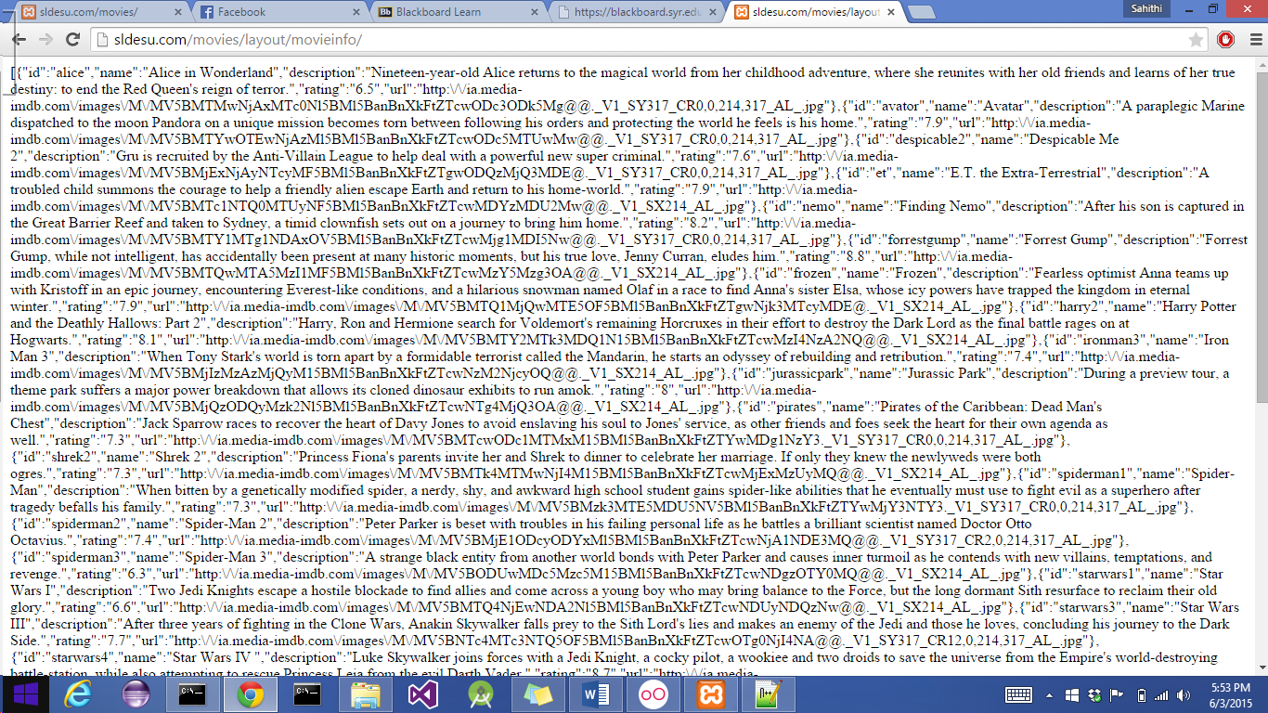

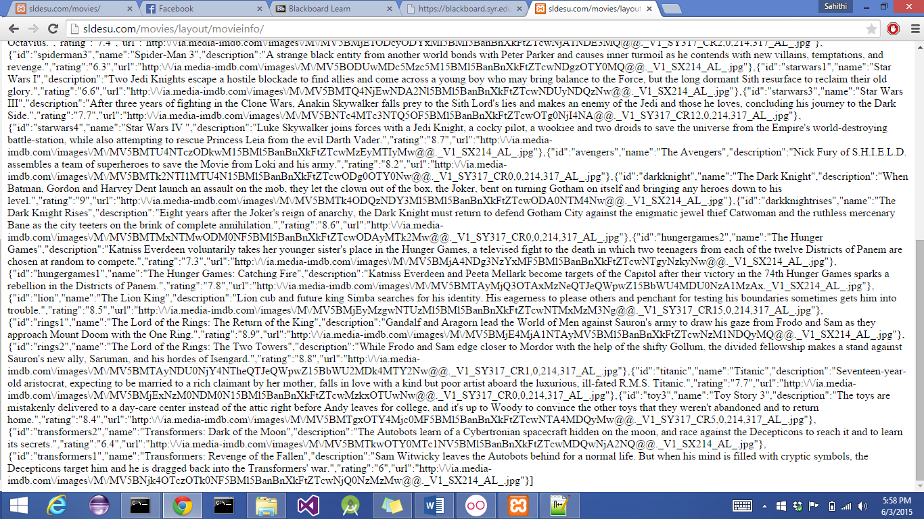

Function getmovies() code:

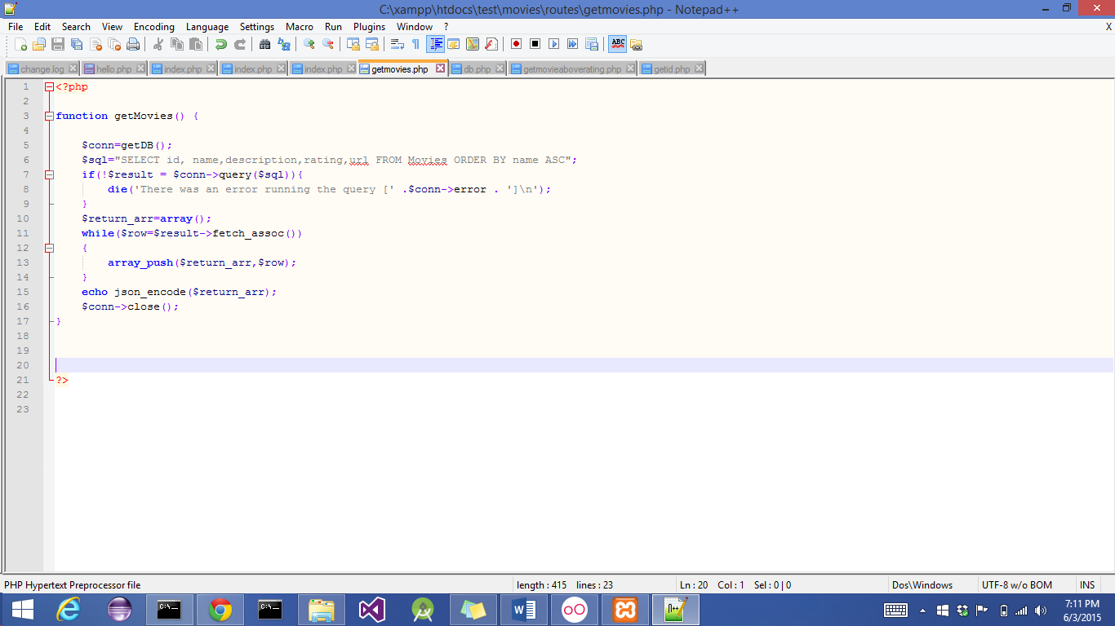

1. When a user types this URL: www.example.com/movies/rating/8.0, the server should return an array of json objects containing all the movies with the rating larger than 8.0. The number 8.0 should be replaced by whatever is typed, but the prefix www.example.com/movies/rating/ should be the same. You should write the server-side code

Result:

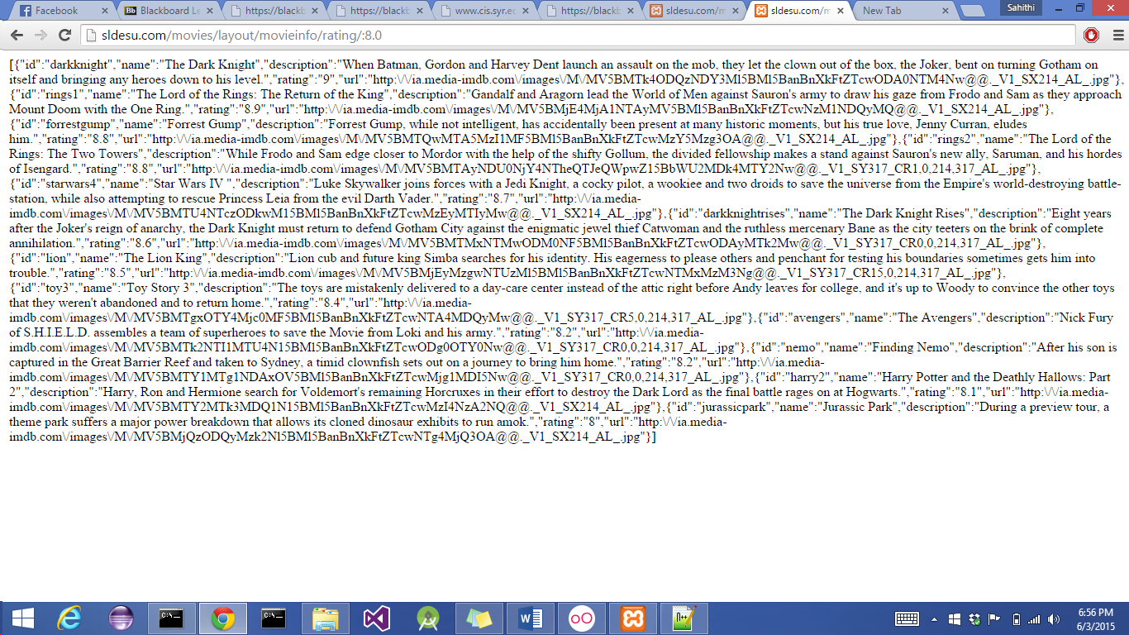

Function :

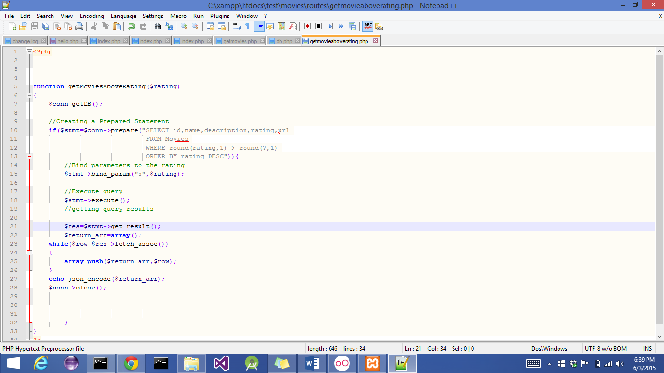

1. When a user types this URL: www.example.com/movies/id/titanic (there is no “/” at the end of the URL), the details of movie titanic should be returned. Your server-side code should return a single json object, which is like what you get from

Result:

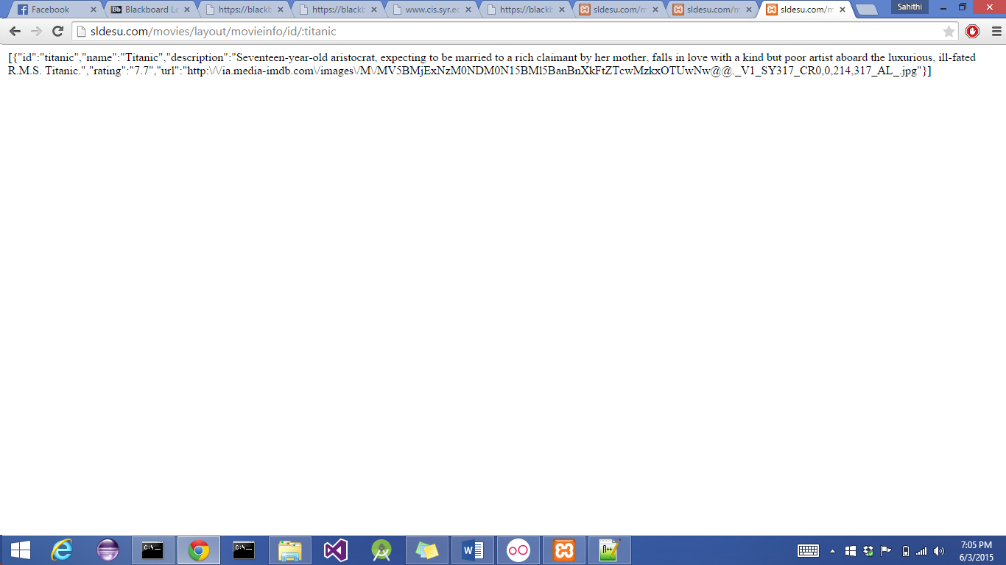

Function:

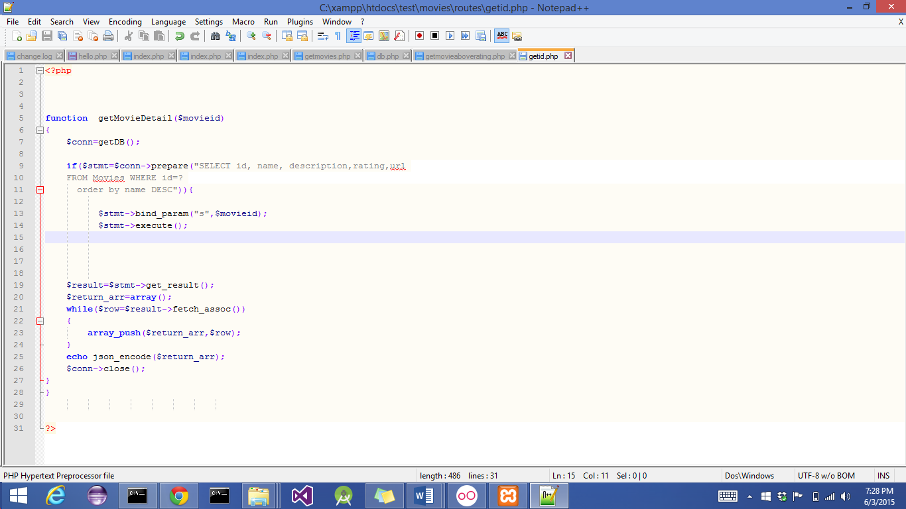

Index.php Code

